Name: Rishika Soni
Section: A sem II
RollNo.: 48
Batch : A3

Practical No.1
Q. Implementation of DDL commands of SQL with suitable examples
a) Create table b) Alter table c) Truncate table d) Drop table
Implementation of DML commands of SQL with suitable examples
- Select b) Insert c) Update d) Delete

Introduction:

What is DDL?
DDL (Data Definition Language) is used to define, create, modify, and delete database objects such as tables, views, indexes, etc.
Common DDL commands are:
- CREATE
- ALTER
- TRUNCATE
- DROP

- CREATE TABLE
- Used to create a new table in the database.
Syntax:
CREATE TABLE table_name (
column1 datatype,
column2 datatype,
...);

ALTER TABLE

Used to modify the structure of an existing table.
You can:
✔ Add a column
✔ Modify a column
✔ Delete a column

Syntax:
ALTER TABLE Student
ADD Marks INT;

TRUNCATE TABLE

Purpose:
Used to remove all records from a table permanently, but the table structure remains.
Syntax:
TRUNCATE TABLE table_name;

DROP TABLE

Purpose:
Used to delete the entire table permanently including its structure and data.

Syntax:
DROP TABLE table_name;

What is DML?
DML (Data Manipulation Language) commands are used to retrieve, insert, update, and delete data in database tables.
Common DML commands are:
- SELECT
- INSERT
- UPDATE
- DELETE

SELECT Command

Purpose:
- Used to retrieve data from a table.

Syntax:
- SELECT column1, column2 FROM table_name;

Example 1: Display all records
SELECT * FROM Student;
✔ Displays all rows and columns from Student table.

🔹 Example 2: Display specific columns
SELECT Name, Marks FROM Student;
✔ Shows only Name and Marks.

🔹 Example 3: Using WHERE condition
SELECT * FROM Student WHERE Marks > 70;
✔ Displays students who scored more than 70 marks.

INSERT Command

Purpose:
Used to add new records into a table

Syntax:
INSERT INTO table_name VALUES(value1, value2, ...);

🔹 Example 1: Insert complete record
INSERT INTO Student
VALUES (101, 'Riya', 20, 'BCA', 85);
✔ Inserts one row into Student table.

🔹 Example 2: Insert selected columns
INSERT INTO Student (RollNo, Name, Course)
VALUES (102, 'Aman', 'BSc');
✔ Remaining columns will contain NULL.

UPDATE Command

Purpose:
Used to modify existing records in a table.

Syntax:
UPDATE table_name
SET column=value
WHERE condition;

DELETE Command

Purpose:
Used to remove records from a table.
Syntax:
DELETE FROM table_name
WHERE condition;
(i) Create following tables according to the following definition.
DEPOSIT: Actno, Cname, Bname, Amount, Adate
BRANCH: Bname,City
CUSTOMERS: Cname, City
BORROW: Loanno, Cname, Bname, Amount
Deposit:
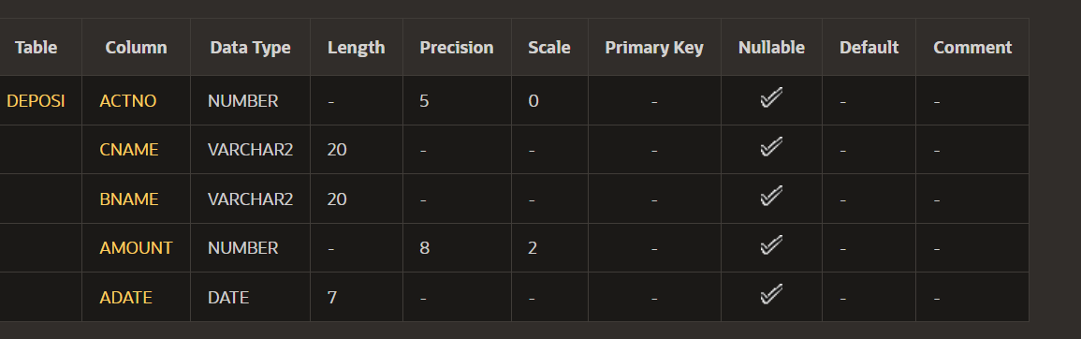
Branch:
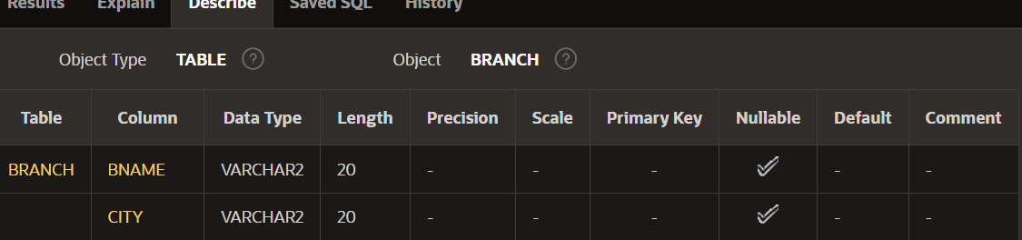
Customer:
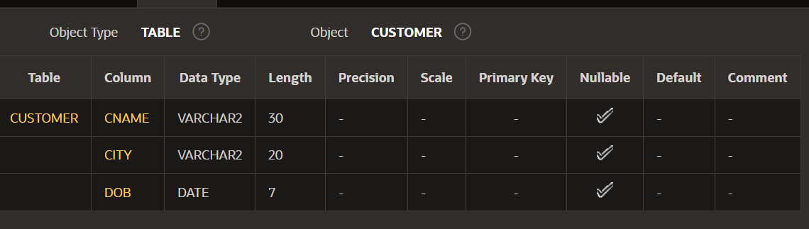
Borrow:
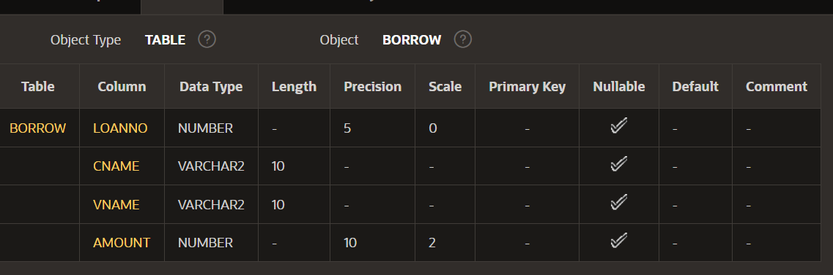
- Add new column DOB into the CUSTOMER table.
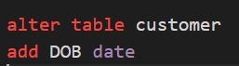
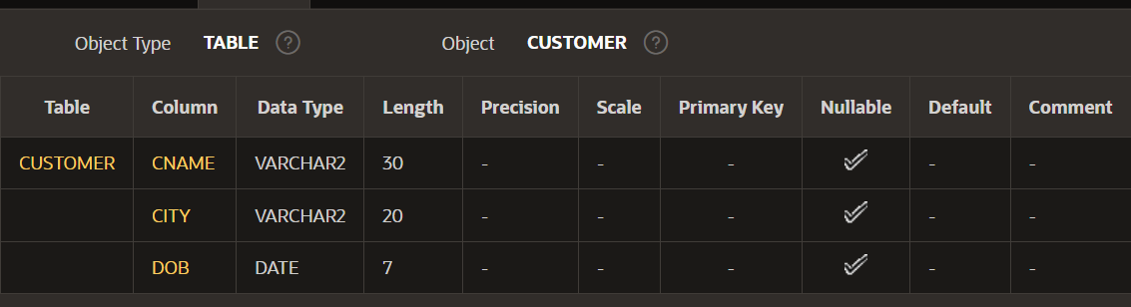

- Add LOCATION column in BRANCH table
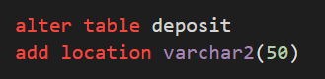
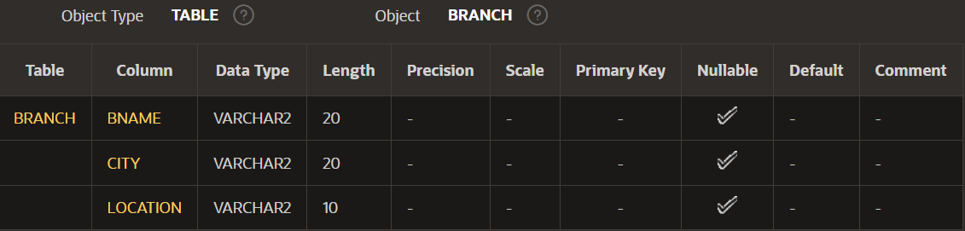
- Modify customer name space to 30 characters.
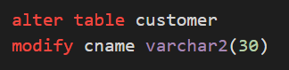
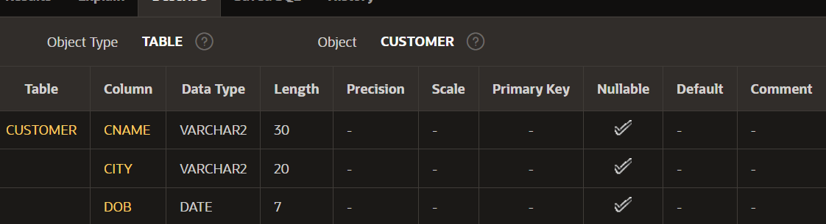
- Change datatype of Loan number column to numeric type.


- Delete LOCATION column.

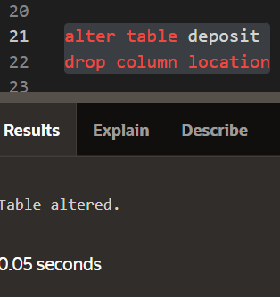
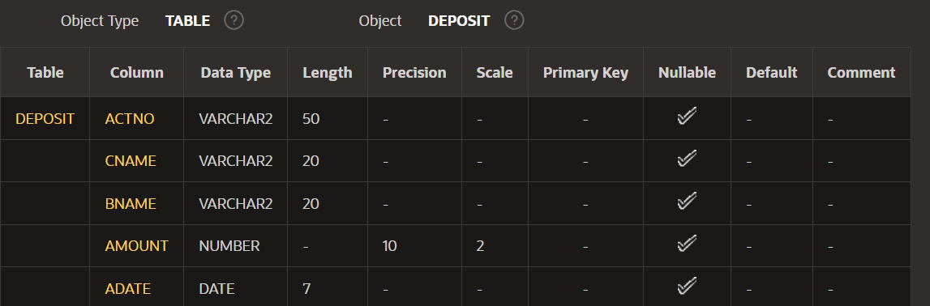

- Create DEPOSIT_TMP table that contains all information of DEPOSIT table.
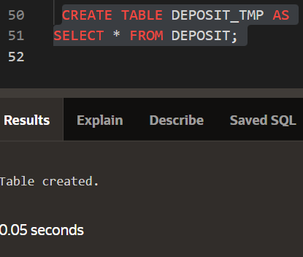
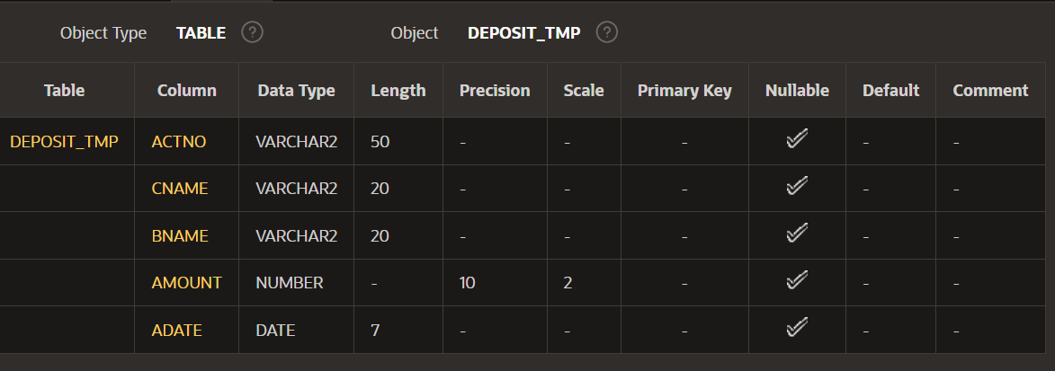
- Create BRANCH_TMP table that contains only structure same as BRANCH table.
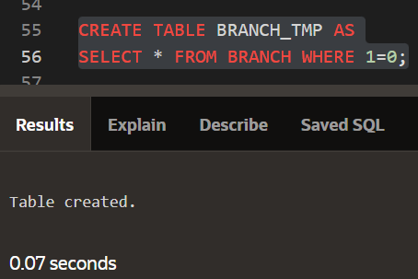
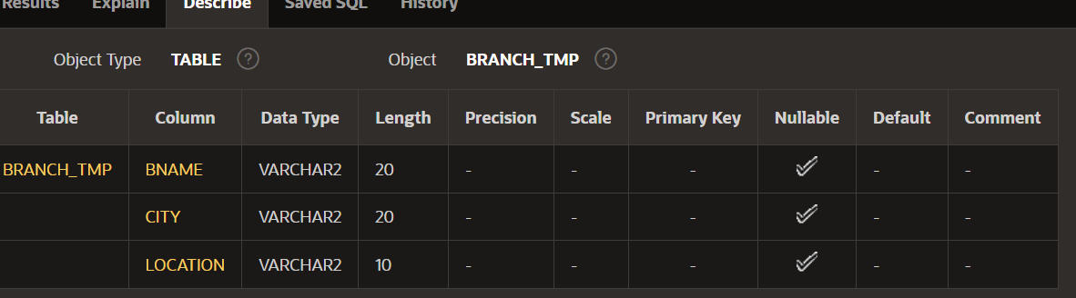

- Remove all rows from DEPOSIT_TMP table.
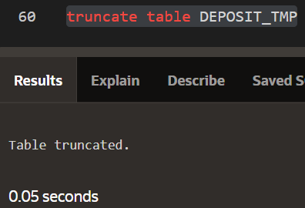

- Delete DEPOSIT_TMP.
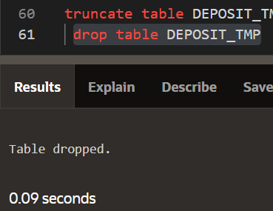

(ii) Insert the data as shown below.

